“Le Nouveau Salon”

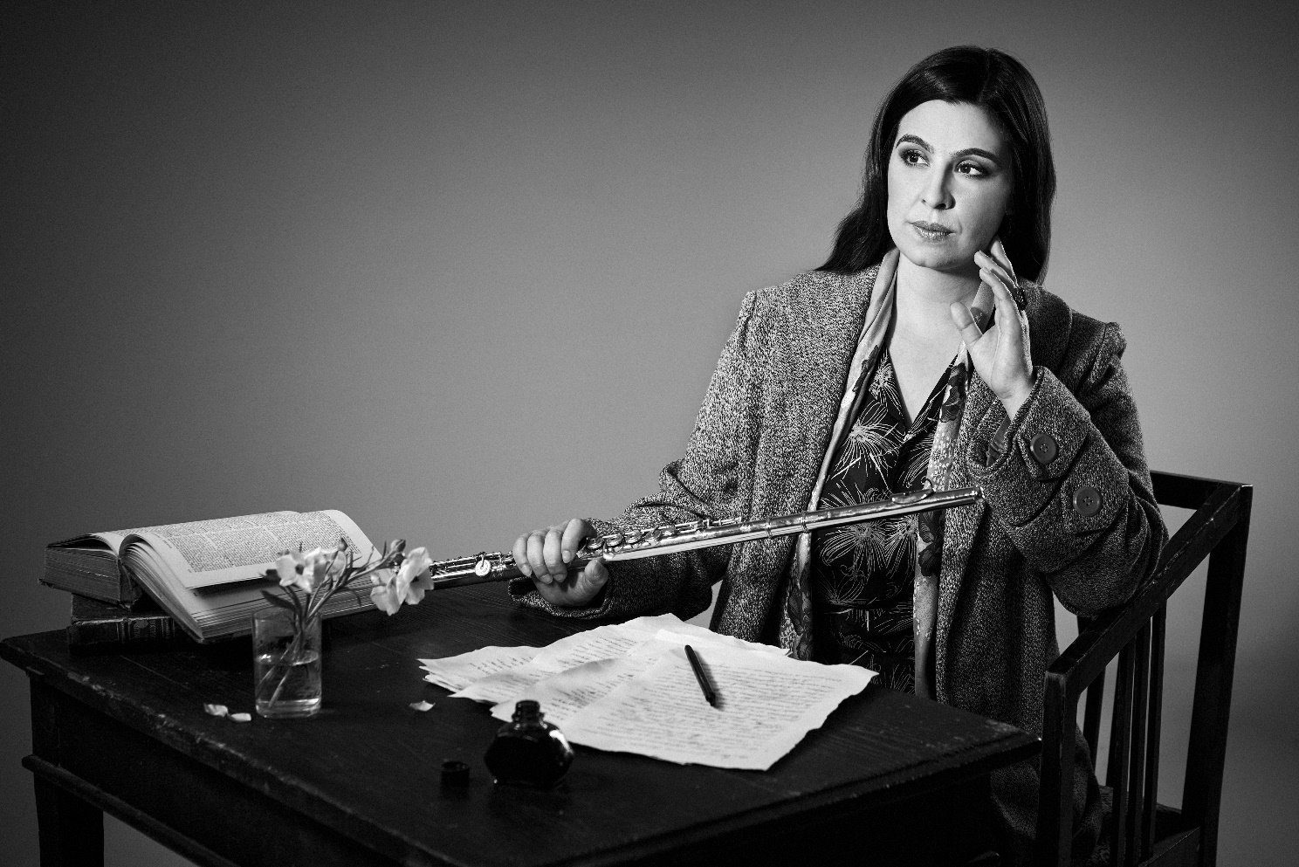

This recording represents my personal journey as a French flutist, inspired by Marcel Proust “A la recherche du temps perdu”. In his novel, the author undergoes a series of sensory experiences which make him vividly relive moments from his past, the most famous one being the episode of the “madeleine”. For the project at hand, I decided to revisit the pieces that were most formative for my development as a musician, creating my own “Recherche”. I am very happy to have four brilliant musical collaborators at my side, with whom I will present a program with music by Schubert, Ravel, Debussy and Prokofiev.

The Parisian “salons” of the “Belle Epoque” were the prime venues that furthered artistic development and were immortalised in Proust’s writings, himself being a frequent guest in many of these salons. They were often organized by the wives of rich patrons and women played a central role in organising these events. Different salons would often compete in presenting the most avant-garde, up-to date artists, musicians and composers of the day.
In this CD, I have decided to re-invent and create my own salon by revisiting my favorite music and remembering the great musical tutors that have helped me along the way.

The first part revolves around Schubert’s Introduction, Theme and Variations on “Trockne Blumen” (Withered flowers) for flute and piano. This is the only chamber music piece using the flute written by Schubert himself. It was modelled after the 18th song (Trockne Blumen) of his cycle “Die Schöne Müllerin” for tenor and piano. The poem by Wilhelm Müller is a Proustian conception “avant la lettre”. The young man in love with the miller’s daughter imagines that the withered flowers that will be lain in his grave will bloom again when she passes the grave. In true Proustian fashion the flowers become an object that brings the past back into the present moment.

In order to have the listener experience some of the original song cycle I have decided to make my own version, combining the three last songs to the flute piece. The flutist starts with the hauntingly beautiful introduction composed by Schubert. After that, the song “Trockne Blumen”, which provides the theme for the flute variations is sung in its entirety by the tenor. Evocations of “Der Müller und der Bach” (Nr. 19, The Miller and the Brook) and “Des Baches Wiegenlied” (Nr. 20, The Brook’s lullaby) intertwine and appear at various moments throughout the “new” piece. The voice of the tenor breaks through the virtuosic variations for flute and piano, complementing and enriching the flute register, bringing poetic words to the music; sometimes interrupting, sometimes interlacing and reflecting each other, the voice and the flute are in constant symbiosis with the piano, forming a new intimate chamber music trio.

I first discovered Schubert’s masterpiece “Introduction, Theme and variations” when preparing for my final graduation concert at the “Conservatoire National Supérieur de Lyon”, under the inspiring guidance of master flutist Philippe Bernold. I consider this piece to be one of the deepest and most profound works in the flautist’s repertoire and it just keeps growing in stature as I continue to study it over the years.

The central part of the CD reflects my French roots and the symbolic worlds of Maurice Ravel and Claude Debussy. It seems that Proust felt particularly connected to their music. I would like to think that Ravel’s “Sonata nr. 1 for violin and piano” and/or Debussy’s “Syrinx” were performed in one of the salons that both Ravel and Debussy frequented so it is not impossible that Proust might have been in the audience.

I decided to arrange Ravel’s “Violin Sonata nr. 1” for flute, which suits the instrument particularly well due to its gentle, airy tone colours. In the next track, I recite the poem by Gabriel Mourey from Psyche (Acte 3, scene 1) for which the centrepiece of this whole recording was composed: “Syrinx” for solo flute, allegory of the flute, followed by my own interpretation of it.

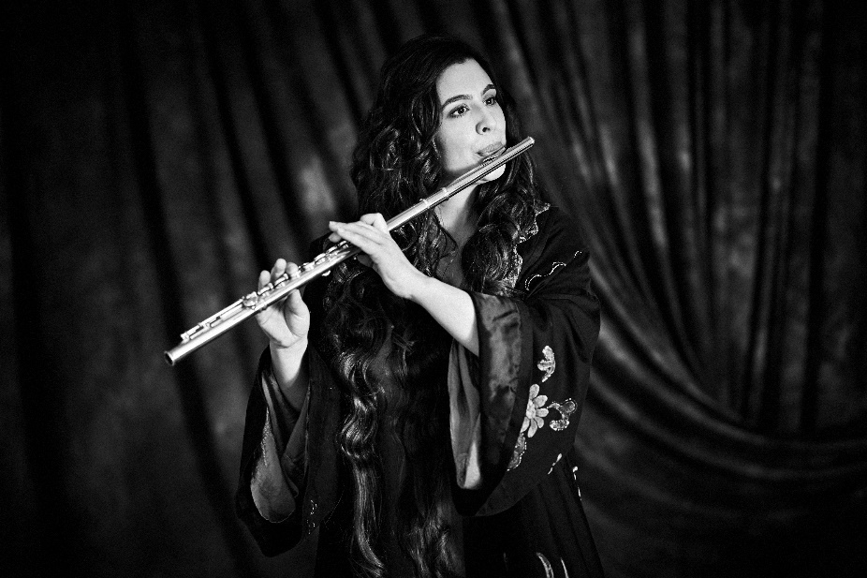
Another event that could not have escaped Proust’s attention was the arrival of the “ballets russes” in Paris in 1909; Diaghilev and the Russian composers he brought with him stirred up an artistic revolution in Paris which deeply altered the course of the arts in the twentieth century. The last chapter of this recording focuses on Sergei Prokofiev, who moved to Paris in 1923 and frequented Winnaretta Singer (princess de Polignac)’s salon. Proust also regularly attended the same salon. I chose to re-invente Prokofiev’s sonata for flute and piano, a work he himself rearranged for violin and piano. The amount of discussion among flutists and violinists about which version should take precedence over the other inspired me to create my own version, constantly mixing the two instruments over the course of the four movements. In my opinion, it shows the full strength and depth of the piece using the specific qualities of both instruments closely interwoven with the piano.

I particularly explored this piece in London, at the Royal Academy of Music under the influence of another great mentor: William Bennett, who opened the doors of freedom and personal interpretation to me. Since living in the Netherlands, I have had the chance to dive deeper and deeper into this sonata, together with the amazing pianist Maarten den Hengst. His other collaboration with the violinist Floor Le Coultre prompted me to arrange this version for the three of us.

This project is a Proust “mise en abyme”, embedding one story into another, in partnership and long-lasting collaboration with special musicians. It suggests multiple facets and layers for the players and the listeners.

“ La musique est peut-être l’exemple unique de ce qu’aurait pu être- s’il n’y avait pas eu l’invention du langage, la formation des mots, l’analyse des idées- la communication des âmes. “, Marcel Proust, « La Prisonnière » (“Music is perhaps the unique example of what could have been- if there had not been the invention of language, the formation of words, the analysis of ideas- the communication of souls.")

Sarah Ouakrat
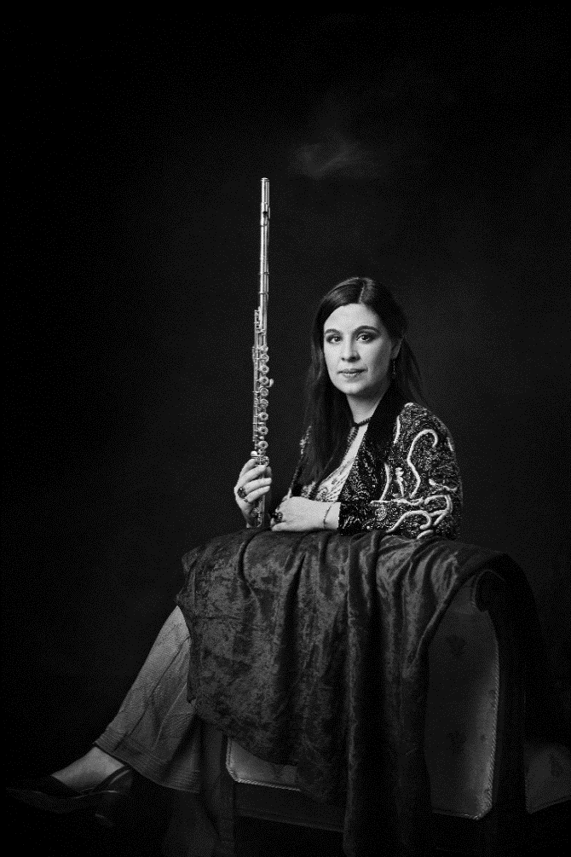
Musicians:

Sarah Ouakrat, flute
Floor Le Coultre, violin
Maarten Den Hengst, piano
Ivana Alkovic, piano (Ravel)
Michael Bennett, tenor

Sound engineer: Guido Tichelman
Visual artist: Kaupo Kikkas

Recoding location:
Westvest 90, Schiedam (Nov. 21-24 2022)

Release: March 2023

Supported by the Sena Muziekproductiefonds

CD tracks:
- Schubert, Introduction on “Trockne Blumen” for flute and piano (2,50’)
- Schubert, lied “Trockne Blumen”, for tenor flute and
Piano, new theme (3,23’)
- Schubert, Variations I, II, II, IV for flute and piano (7,20’)
- Schubert, new Variation V, with extract from “Der Müller und der Bach”, for flute tenor and piano (2,20’)
- Schubert, Variation VI (3,02’)
- Schubert, new Variation VII, with ending “Des Baches Wiegenlied”, for flute tenor and piano (5,45’)
- Ravel “Sonata nr. 1 Posthume”, for flute and piano (16’)
- Debussy “Syrinx” poem (by Mourrey, Psyche) recited by Sarah Ouakrat and solo (4’)
- Prokofiev “new Sonata nr. 2 in D Major” for flute, violin and piano, 1st mvt “Moderato” (8’)
- Prokofiev’s Sonata, 2nd movement “Presto” (5’)
- Prokofiev’s Sonata, 3rd movement Andante” (4’)
- Prokofiev’s Sonata, 4th movement “Allegro con brio” (6,45’)

Total duration of the CD: around 70 minutes

